Paper Title: Times New Roman, 14pt Bold, Centered, Interligne 1.5

Authors (full names), underline presenting author: Times New Roman, 10pt Bold, Centered^{a, b}
- Laboratory, Affiliation, Address; Times New Roman, 8pt Italic, Centered
- Laboratory2, Affiliation2, Address; Times New Roman, 8pt Italic, Centered
E-mail: Times New Roman, 8pt Italic, Centered

ABSTRACT (Times New Roman, 10 pt, Justified): Max 150 Words
An abstract not exceeding 120 words (10 pt) must include a brief description of the obtained results. It should describe the scope, hypothesis or rationale of the work and the main findings.
Papers must be submitted online (WinWord format, do not exceed 4 pages) with the information form via the website (Max: 2MB): https://atuted.org.tn/icace-2020/inscriptions-et-depot-des-resumes/

KEYWORDS (Times New Roman, 10 pt, justified, Small Capital): 4-5 keywords (10pt, semicolons separated Keyword 1, Keyword 2, Keyword 3, Keyword 4.
- INTRODUCTION
The paper must be written in English. It must be structured in the following way: abstract, introduction, material and methods, results and discussions, conclusion and references.
Please use the following guidelines:
- Use DIN A4 Format (297 x 210 mm).
- Margins: top, left, bottom and right 20 mm each.
- The paper must be written in single line spacing
- The paper has to be written in PC WINWORD format.
- Use Times New Roman Front, 11 pt.
- The font formats are: paper title: 14 pt bold, authors’ names: 10 pt, affiliations: 10 pt abstract: 10 pt, key words: 10 pt.
- Main headings: 12 pt, bold, capital letters, subsidiary headings: 10 pt, bold, numbered, left justified; text: 11 pt.
- Titles Paragraphs should be justified. Do not separate paragraphs with blank lines. Lines and paragraph spacing before and after 6pts with a Simple Line Spacing.
- MATERIAL AND METHODS
A brief description of the experimental approach and the investigative tools used
- RESULTS AND DISCUSSIONS
  - Subsidiary headings
There must not be more than three levels of headings. They must be in bold letters with only initial capital, Times New Roman, 11pt, Bold
  - Tables and figures
Tables and figures must be mentioned in the text and placed after their first citation. They must be numbered using Arabic numerals. Use Times New Roman, 10 pt for the headings and captions. Table headings must be centered above the tables, and figure captions must be centered below the figures as shown below:
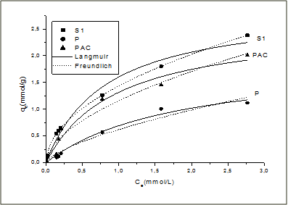
Figure 1: Title of the figure

Table 1: Title of the table, left aligned
N | X | Y | Z
1 | 11 | 21 | 31
2 | 12 | 22 | 32
3 | 13 | 23 | 33
  - Equations and unit
Equations must be placed on a separate line with a blank space above and below. The equations should be clear and must be numbered consecutively in the right outer margin. Expressions used should be explained in the text.
E = m.c² (1)

Please use IS (International System of Units) system for the definition of the units.
- CONCLUSION
The conclusion must summarize the main results clearly and concisely
REFERENCES
Reference numbers in the text should be enclosed in square brackets. The references must be listed in the same order as that quoted in the text. All references listed must be directly cited in the body of the text. Examples are given below:

[1] Author(s), Title of the paper, Name of the Journal (in italics), 2018, Vol.1, No.1, 35-42.
[2] Author(s), Title of the Book (in italics), Publisher, Place of Publication, 2018, 235-242.
[3] Author(s), Title of the conference paper, Book of Proceedings, Conference location, 2018, 235-242.

